"Thermal Degradation and Pyrolysis of Ablative Materials: Enhancing Reentry Vehicle Safety"

Joann Mathai Alex
Dr Duncan Weathers
Dr Yan Jiang
Department of Physics, University of North Texas, 1155 Union Circle, #311427, Denton, Texas 76203

20 July 2025
This thesis bridges two disciplines: physics and space engineering. During reentry into Earth's atmosphere, space vehicles encounter intense heat due to the high velocities at which they travel. As the vehicle moves at hypersonic speeds, the air molecules in front of it are compressed and cannot dissipate quickly enough, leading to extreme temperatures. This phenomenon, caused by kinetic friction and the resulting shockwave, generates significant aerodynamic heating, which must be managed to protect the vehicle's structural integrity. One of the solutions used in this scenario is ablation where a certain material usually composed of resin and fiber is coated along the exposed area. This material is engineered to gradually degrade in a process known as pyrolysis. During pyrolysis, the material heats up and chemically decomposes, transforming into gas. This gas then escapes through the porous structure, carrying away heat and helping to protect the vehicle's integrity by reducing the amount of heat transferred to the underlying structure. Python was used to calculate the heat flux experienced around the stagnation point on an 8000 kg capsule entering Earth’s atmosphere at about 7 km/s. COMSOL was then employed to simulate the exposure of the capsule to the obtained heat flux, enabling detailed observations of its thermal response. The primary objectives in optimizing the ablative material were to minimize heat conduction to the underlying structure and to ensure that the material retains a minimal thickness after enduring the intense heat of reentry.
CHAPTER 1: Re-entry Physics
The dimensions chosen for the capsule were typical to re-entry crew vehicles such as the Orion Crew Module or the SpaceX Dragon 2. With total payload of 8000 kg and a base diameter of 4 meters, and shield height of 0.75 meters, these were the main measurements contributing to the overall aerodynamics forces. 3 dimensional cartesian coordinates were chosen with an initial position of about 121 km above the Earth’s surface. Initial speed of the capsule was about 5.7 km/s which is well withing the hypersonic range (above Mach 5). The three fundamental forces acting upon the capsule were the drag, and lift forces as well as the weight force. In this thesis, each one will be inspected closely; the drag force is computed using the physics equation
$F_{D}=-\frac{1}{2}C_{D}ρA_{eff}|\overline{V}|\overline{V}$ –(1)
where $C_{D}$ represents the drag coefficient, $ρ$ as the air density, $A_{eff}$ as the effective area, and $\overline{V}$ as the velocity vector. Negative sign seen in front of the equation shows that the force acts against the velocity, slowing down the craft. The effective area exposed to drag was computed with a simplified relation of base radius to the angle of attack “$θ$”.
$A_{eff}= {{πR}_{B}}^{2}cos⁡(θ)$ –(2)
The angle of attack is defined to be the angle between the velocity vector and the axis of symmetry going through the capsule. $θ$ was set to be ${15}^{°}$ above 3 km/s to generate lift and ${-25}^{°}$ below 3km/s to stabilize for a steeper descent. The air density at each altitude level were calculated using two models depending on whether the temperature at that level was assumed to vary or not. In altitude levels where the temperature is proven to vary, this equation was used $ρ= {ρ_{b}[\frac{T_{b}-(h-h_{b})L_{b}}{T_{b}}]}^{(\frac{g_{0M}}{RL_{b}}-1)}$ –(3)
and at levels where temperature did not vary as much,
$ρ= ρ_{b}e^{[\frac{-g_{0}M(h-h_{b})}{RT_{b}}]}$ –(4)
Here the subscript b refers to a reference base height and h stand for the height at which the capsule is to be at the any moment. T, $g_{0}$, R, all stand for temperature, gravity constant, and universal gas constant respectively. L is the lapse rate for the altitude level in consideration and M is the molar mass of air. There are 7 different layers with combinations unique lapse rate/constants depicted on the Wikipedia page for the barometric formula.
Layer number | Base altitude [m] | Density at base [kg/m^3] | Standard temperature [K] | Temperature lapse rate [K/m]
0 | 0 | 1.2250 | 288.15 | 0.0065
1 | 11,000 | 0.36391 | 216.65 | 0.0
2 | 20,000 | 0.08803 | 216.65 | -0.001
3 | 32,000 | 0.01322 | 228.65 | -0.0028
4 | 47,000 | 0.00143 | 270.65 | 0.0
5 | 51,000 | 0.00086 | 270.65 | 0.0028
6 | 71,000 | 0.000064 | 214.65 | 0.002
Table 1: This shows the constants and lapse rates relevant to each altitude level for the calculation of air density.
Finally, the last piece of the puzzle for the drag force was the drag coefficient “$C_{D}$” which was set to be 2.5 for desired results. This thesis will now move on to discussion for the lift force which is the second component that influence the capsule acceleration. The physics equation used here is
$F_{L}=\frac{1}{2}ρC_{L}{πR_{b}}^{2}sin⁡(θ){|\overline{V}|}^{2}\frac{\overline{V}×(\overline{V}×\overline{g})}{{|\overline{V}|}^{2}|\overline{g}|sin⁡(φ)}$ –(5)
$\overline{g}$ is the gravity force vector which was obtained by dividing the weight force components with the mass of the capsule. The angle “$φ$” is made between the velocity trajectory and the gravity force direction. The cross product in the numerator is meant to produce the direction of lift experienced throughout the descent. This direction is perpendicular to the velocity field while the drag force is opposite to the velocity field. Sine is used in the effective area as opposed to cosine because lift is proportional to the component of the total aerodynamic force that acts normal (perpendicular) to the airflow. And finally, the coefficient of lift “$C_{L}$” was taken to be 0.3 after testing python simulations a few times for optimal results. The third component that influences the capsule acceleration is the weight force which is governed by Newtons gravitational law. This is from
$$W= \frac{-GM_{E}m}{{|r|}^{3}}\overline{r}–(6)$$
where G is the gravitational constant, $M_{E}$ is the mass of the Earth, m is the mass of the spacecraft, and r is the position vector. The negative sign on the formula indicates that the weight force pulls the mass of the spacecraft towards Earth’s. For initial values, the position vector was decided to be (x= 0.03m, y = 6492000m, z = 0.03m); here the azimuthal was decided upon the x-z plane for the sphere that is Earth and y represented the vertical with the estimation of earth’s radius as 6,371,000 meters. This meant that the initial altitude was $\sqrt{2×{0.03}^{2}+{6492000}^{2}}-6371000$ = 121,000, about 121 km above earth’s surface. Initial velocity optimization was (x = 4041.5 m/s, y = -159.5 m/s, z = 4041.5 m/s); the vertical descend is slower initially to reduce G forces that may be experienced later during the flight. The G force is something that need to be considered in this experiment as it can have a disastrous effect on the cargo and astronauts aboard if it exceeds 6.0. In the python simulation that ran, G force was observed at times to go a little above this margin for a brief time but not too much that it became a major concern. This is the equation for the G force:
G-force = $\frac{|V_{new}-V_{old}|}{dt×9.81}–(7)$
where dt was taken to be exactly half a second. The small dt ensures more accurate data throughout the simulation. Iterations would be done based on the classical mechanics (Force = mass times acceleration) and the weight, lift, and drag forces were summed up and divided by the mass of the spacecraft to get new accelerations in each direction and these were multiplied by dt (0.5 seconds) to get new velocity vector. The new velocities were then multiplied by dt again to get new positions which would offer a new altitude. This altitude may give newer air density, pressure, etc. using the appropriate formulas which would then affect the three main forces. This cycle is the main engine that drove this simulation and each time the loop ran, different data points were stored for plotting graphs which gave useful insights into the trajectory. For example, the simulation gave a natural-like plot for the heat flux experienced for a re-entry like this. In the study by Tahsini and Tadayon Mousavi [1], the convective heat flux experienced by a reentry vehicle is estimated using an empirical correlation expressed as:
heat flux =$1.83×{10}^{-4}v^{3}\sqrt{\frac{ρ}{N_{r}}}–(8)$
where $N_{r}$ is the nose radius of the heat shield; since it is like a protruding shell, it was averaged using the length from the base center to shield tip of 0.75 meters. Nose radius was calculated to be $\frac{2^{2}+{0.75}^{2}}{2×0.75}$ which is approximately 3.16 m. Equation (8) is an empirical formula that folds in a lot of complicated physics into just one line. It takes into account how the speed of the air molecules and their density along with the shape of the shield whether its blunt or not can affect overall heat flux.
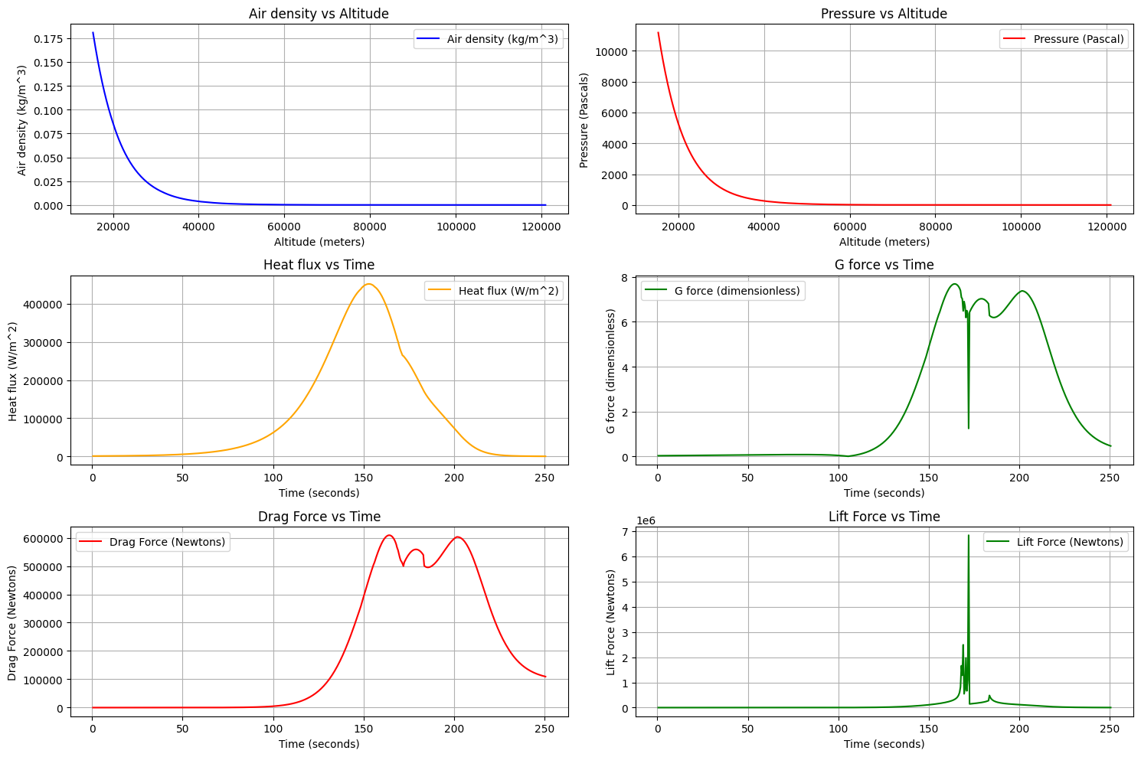
Figure 1: it shows several fundamental forces involved in the flight. G force can be seen to be above 6 G for about a minute. Lift force saw a strange spike at about 175 seconds into the flight possibly due to a change in angle of attack or other aerodynamic effects. Air density and pressure looked natural throughout the altitude descend. Heat flux, at around 155 seconds in, had reached a maximum of half a million watts per meter square which is typical of such re-entry missions.
Air pressure and ambient temperature were not needed to calculate the heat flux but they would later come into play when simulating the heat shield. Pressure is calculated in a similar manner to air density but instead of altitude, the geopotential height was used. This is a simple relation: $Geopotential height= \frac{altitude}{1-(\frac{altitude}{6371000})}-(9)$
this was done to simply the atmospheric model as gravity would vary with height and $g_{0}$ was assumed constant.

Layer number | Base altitude (Geopotential) [m] | Static pressure [pa] | Standard temperature [K] | Temperature lapse rate [K/m] | Exponent  $$\frac{g_{0}M}{RL}$$
0 | 0 | 101325.00 | 288.15 | 0.0065 | 5.25588
1 | 11,000 | 22632.10 | 216.65 | 0.0 | N/A
2 | 20,000 | 5474.89 | 216.65 | -0.001 | -34.1626
3 | 32,000 | 868.02 | 228.65 | -0.0028 | -12.2009
4 | 47,000 | 110.91 | 270.65 | 0.0 | N/A
5 | 51,000 | 66.94 | 270.65 | 0.0028 | 12.2009
6 | 71,000 | 3.96 | 214.65 | 0.002 | 17.0813
Table 2: shows pressure data for calculation based on geopotential height above Earth. Two equations depending on the presence temperature variation would be used.
In the pressure calculations, atmospheric layers such as the first and fourth ones shown in Table 2 were ones with not much temperature variations. These would employ this equation
$$P=P_{b}\exp\left(\frac{-g_{0}M\left(h-h_{b}\right)}{RT_{M,b}}\right)-(10)$$
with definitions similar to the density equations discussed earlier. On all the other layers, the equation is modified into
$$P= P_{b}\left(({1-\frac{L_{M,b}}{T_{M,b}}(h-h_{b}))}^{\frac{{g^{'}}_{0}M_{0}}{RL_{M,b}}}\right)-(11)$$
Total pressure experienced just outside the boundary layer of the ablator will also include dynamic pressure which is acquired by a division with base area on drag force. Hence, the total pressure is equal to the atmospheric pressure plus the dynamic pressure. Ambient temperatures at each stage of the re-entry would primarily depend on the time of the year and the location of the globe as well as the altitude but standard averages were extracted from Wikipedia source to have something to work on. With all these information, the thesis can move on to the governing equations that describe the pyrolysis reactions.

CHAPTER 2: Governing Equations
There are four main equations that make up the spinal cord of the chemistry involved. One of them is the Goldstein’s equation that describe rate of change in density. In the paper written by Stepane Alestra and J Collinet [2], it shows as
$$\frac{1}{ρ_{v}}\frac{∂ρ}{∂t}=-({\frac{ρ-ρ_{c}}{ρ_{v}})}^{np}Ae^{\frac{-B}{T}}-\left(12\right)$$
The $\frac{∂ρ}{∂t}$ represents the change in density of the ablator. Subscripts v and c show virgin and char density and they are constant values. np is the order of reaction, and B is the fictitious temperature in pyrolysis. This is an Arrhenius style equation which is meant to initiate density change at a specified temperature. Since manufacturers must specify these values and rarely do, they were estimated for the purposes of the simulation. The second equation that drive the chemistry is
$$-\frac{∂ρ}{∂t}=\overline{∇}∙\overline{{ṁ''}_{g}}-\left(13\right)$$
which guides the computing of density change by relating it to the pyrolysis gas mass flux. This helps in getting useful information such as the gas mass flux in the 2 dimensions used in COMSOL. $\overline{∇}∙\overline{{ṁ''}_{g}}$ can be redefined as $\frac{∂}{∂r}{ṁ''}_{gr}+\frac{∂}{∂z}{ṁ''}_{gz}$ with r and z representing the x and y coordinates respectively. The third equation that governs physics here is
$$\overline{{ṁ''}_{g}}=-\frac{K}{φσ}\overline{∇}P-\left(14\right)$$
also known as Darcy’s law. It shows the direction of flow for the pyrolytic gas that is generated. The ambient pressure around the gas and the outside of the ablator will be different which drives the gas to flow towards that gradient. This gradient is also approximately equal to the temperature gradient as well. The constants here K, $φ, σ$ all consider the permeability of the porous medium, porosity, and kinematic viscosity of the gas respectively. Equation 14 can be re written a
s $\overline{{ṁ''}_{gr}}$ $=-\frac{K}{φσ}\frac{∂ρ}{∂r}-\left(15\right)$
and
$$=\overline{{ṁ''}_{gz}}-\frac{K}{φσ}\frac{∂ρ}{∂z}-\left(16\right)$$
Coefficient variable $\frac{K}{φσ}$ here is drawn from an equation
$${-\left(\frac{{10}^{-7}}{0.001+\left|T\right|}\right)}^{0.7}{(1+|1-χ| ) }^{\frac{2}{3}}-\left(17\right)$$
$χ$ here is the Greek letter to show the composition of the ablator; when it is one, the ablator material is virgin and has not gone pyrolysis and when it is zero, it is fully charred. $χ$ is defined in this context as
$$\frac{ρ-ρ_{c}}{ρ_{v}-ρ_{c}}-\left(18\right)$$
Here, it can be inferred that when the rho variable which is the composite density reach the char density, kai reaches zero. Derivation of equation 17 is through the idea of pore diameter expansion, say when the ablator material has not gone through any pyrolysis yet. Then, the pore volume is $V_{r0}$ and when it slowly starts to lose material, a new pore within the initial pore begins. This volume could be thought of as $V_{pore}=V_{r0}-V_{r}$ and it is proportional directly to the pore diameter cubed. So $d^{2}$ will be equal to the ${{(V}_{r0}-V_{r})}^{2/3}$ and this is substituted into the relation $k=cd^{2}$. And now, k, the permeability is equal to $c{{(V}_{r0}-V_{r})}^{2/3}$ which could be re-written as $C+C^{'}{(1-χ )}^{2/3}$ where the relation $χ=\frac{V_{r}}{V_{r0}}$ was used with common factor folded into the constant outside. The porosity value $φ$ was assumed to be 1 for simplicity here and the kinematic viscosity value $σ$ was expanded as dynamic viscosity $μ$ over gas density. $μ$ is equal to $αT^{b}$ where the value of alpha was determined to be ${2×10}^{-7}$Pa$∙s$ and b to be 0.7 all of which represent typical values of ablative material. In the end, all substitutions for this came up to be $-\frac{Kρ}{φμ}=-\frac{C+C^{'}{\left(1-χ \right)}^{\frac{2}{3}}}{αT^{0.7}}=-\frac{C(1+{\left(1-χ \right)}^{\frac{2}{3}})}{αT^{0.7}}$ = ${-\left(\frac{{10}^{-7}}{0.001+\left|T\right|}\right)}^{0.7}{(1+|1-χ| ) }^{\frac{2}{3}}$. The addition of the 0.001 and the absolute values are to just facilitate smooth computation avoiding zeros in the denominator. The fourth equation is used in the heat flux module, and it is
$$ρC_{p}\frac{∂T}{∂t}=K∇^{2}T+\left(h_{g}-\overline{h}\right)\frac{∂ρ}{∂t}- \overline{{{\dot{m}}^{''}}_{g}}∙\overline{∇}h_{g}-\left(19\right)$$
This relates the density of the composite to the three terms on the right-hand side; the first on the right-hand side, which is conduction term that depends on a constant K and change in temperature. The second term which shows how the internal energy due to decomposition. Here, when $h_{g}$ (the gas enthalpy) is larger than $\overline{h}$ (the ablator enthalpy), the term multiplies itself with $\frac{∂ρ}{∂t}$ which itself is negative thereby giving a negative contribution. It shows energy sink because it removes energy from the solid system which is exactly the purpose of ablation. The third term on the right-hand side is a convective energy transport by gas flow; it either heat or cool the region depending on the gas enthalpy gradient. To ensure that COMSOL understands the generation of pyrolytic gas and its flow, the equation 14 was taken to have a divergence on both sides and set the right-hand side equal to the change in ablator density. In other words, the Goldstein equation was coupled with the Darcy’s law giving this:
$∇∙\left(-\frac{K}{φσ}\overline{∇}P\right)=-({\frac{ρ-ρ_{c}}{ρ_{v}})}^{np}Ae^{\frac{-B}{T}}ρ_{v}-\left(20\right)$.
Moving onto heat flux, the enthalpy of the gas was decided to be
$$h_{g}=(f+1)\frac{B_{mann}T}{m}-\left(21\right)$$
where f is the degrees of freedom (5 in this case), $B_{mann}$ is the Boltzmann constant, and m is the average molecular mass. This required an educated assumption of the gases involved during pyrolysis. Compounds that most likely appear in this process are water vapor, hydrogen, carbon monoxide and carbon dioxide. And the average molecular mass was taken using this formula $Σxm$ where x is the percent of the element. So, this is about 3.7% CO, 1.1% ${CO}_{2}$, 48.9% $H_{2}O$, and 33.4% $H_{2}$ which gave an average molecular mass of $1.82715842×{10}^{-26}$kg. The specific heat capacity of the virgin composite was necessary to calculate the enthalpy of the ablator. This heat capacity denoted as $C_{v}$ would require the simulation to know $C_{r}$ and $C_{c}$ (both resin and char heat capacities as well). So, $C_{v}$ is given by this equation:
$$C_{v}= C_{r}+\left(C_{c}-C_{r}\right)\left(\frac{ρ_{c}}{ρ_{v}}\right)\left(1-0.6\right)-\left(22\right)$$
$.$ 0.6 here describes that the composite in its initial stage is 60% resin and 40% fiber. Char and resin heat capacities were estimated at the beginning of each simulation to be realistic as possible. And finally, the ablator enthalpy is acquired directly from this using
$$h=\left(ρ_{v}C_{v}T-ρ_{c}C_{c}T\right)\left(\frac{1}{ρ_{v}-ρ_{c}}\right)-\left(23\right)$$
. This equation is derived from the study by Tahsini and Mousavi [1] where it is mentioned that the enthalpy of ablator h is equal to $\frac{ρ_{v}H_{v}-ρ_{c}H_{c}}{ρ_{v}-ρ_{c}}$ where $H_{v}=\int_{0}^{T}{C_{v}dT}$ and $H_{c}=\int_{0}^{T}{C_{c}dT}$ but assumptions were made that the specific heat capacities do not depend on temperature to change significantly so they were treated that way. Also from the same source, a relation was discovered for the ablator heat capacity $C_{P}$ to its virgin heat capacity $C_{v}.$It is
$$C_{P}=\frac{1}{ρ}(ρ_{v}C_{v}χ+(1-χ)ρ_{c}C_{c})) -\left(24\right)$$
Equations 21 and 23 care for the energy sink term which leaves attention to the next term, the convective energy transport. $\overline{{ṁ''}_{g}}∙\overline{∇}h_{g}$was set equal to $\overline{{ṁ''}_{gr}}\frac{∂h_{g}}{∂r}+\overline{{ṁ''}_{gz}}\frac{∂h_{g}}{∂z}$ which is simply an equivalent way of describing it. To finalize the heat flux module information, surface energy balance was considered. In addition to the actual heat flux experienced at the surface of the ablator, two more terms that take away energy from this heat flux was included. One of them being radiation from the surface or blackbody radiation with this equation:
$$B_{radiation}=5.67×0.9×{10}^{-8}\frac{W}{m^{2}}({T_{o}}^{4}-{T_{i}}^{4}) -\left(25\right)$$
0.9 is an emissivity constant characteristic of the ablative material.

CHAPTER 3: Running COMSOL Study
Designing the capsule was only a matter of lines and curves conjoined together in 2-dimensional axis-symmetric setup. After deciding the base radius to be 2 meters, a point was placed there and a polygon was drawn going slanting toward the roof area, from there a circular arc was placed that touch the line of symmetry. Similarly, the base also had a circular arc to represent the heat shield with its tip at about 0.75 meters from the base. These three lines were selected as a group and selected to be “composite curve” for better organizing. Two more such composite curves would then be created outside of the already existing one to represent the aluminum structure and the ablative layer. For the polygon lines, the x values were adjusted to make the base 10 mm and the ablator 25 mm. For the arcs, the radius would be adjusted to accommodate the design. The result would then be something as shown.
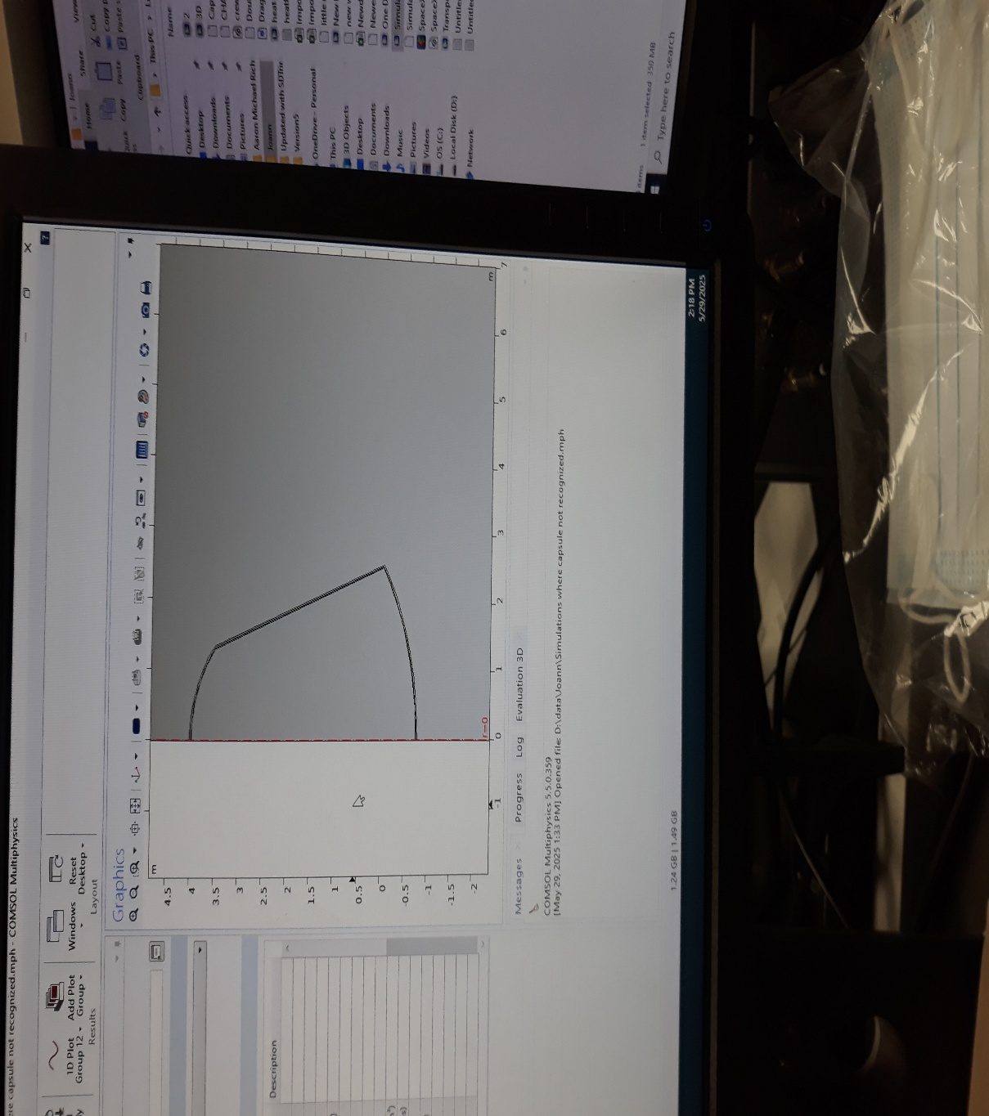
Figure 2: The base structure with the 25 mm thick ablative layer. The thin size may be hard to see unless zoomed in, but this is the capsule which will be tested on, the inside is hollow with just air at room temperature.
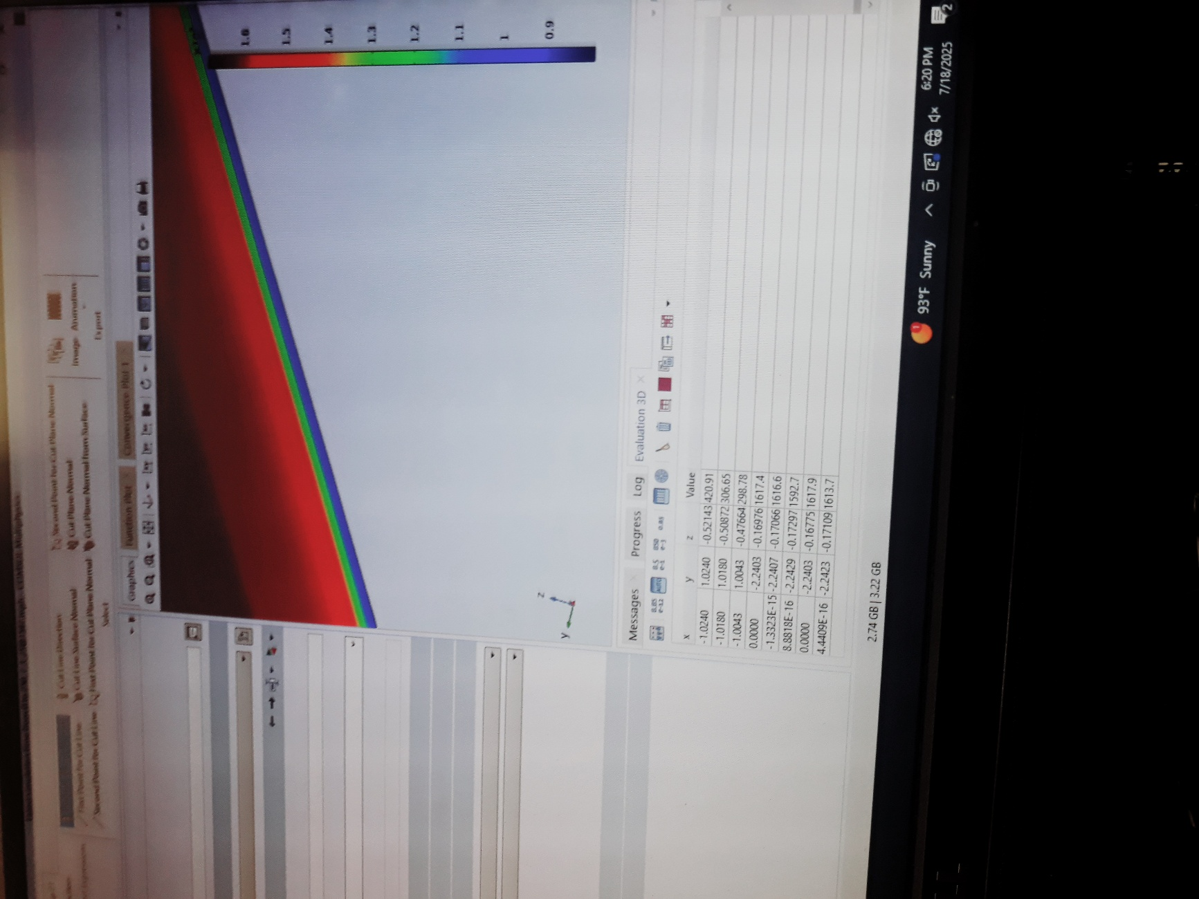
Figure 3: Initial simulations showed the ablator worked very well with the current specifications, so we made the material thinner (went from 25 mm to 10 mm). The color gradient here shows the region where the virgin material has pyrolyzed. The darker inner region mostly maintained the density that they started with.
So, we changed a few parameters to simulate a new material. These are properties that simulate the AVCOAT ablative material used in the Orion crew module.
PROPERTY | OLD VALUE | NEW VALUE
Composition | 60% Resin, 40% Fiber | 55% Resin, 45% Fiber
Specific heat capacity of resin | 1133.33$\frac{J}{kg∙K}$ | 1100$\frac{J}{kg∙K}$
Specific heat capacity of fiber | 1050$\frac{J}{kg∙K}$ | 740$\frac{J}{kg∙K}$
Thermal heat conductivity of resin | 0.48$\frac{W}{m∙K}$ | 0.2$\frac{W}{m∙K}$
Thermal conductivity of fiber | 0.08$\frac{W}{m∙K}$ | 1.4$\frac{W}{m∙K}$
Density of virgin | 1620$\frac{kg}{m^{3}}$ | 544$\frac{kg}{m^{3}}$
Density of fiber | 840$\frac{kg}{m^{3}}$ | 2200$\frac{kg}{m^{3}}$
Gas composition | 48.9%$H_{2}O, 3.7\%CO, 1.1\%CO_{2}, 33.4\%H_{2}$ | 42%$H_{2}O, 27\%CO, 13\%CO_{2}, 8\%CH_{4}, 6\%H_{2}$
Table 3: shows values that been replaced for a new material simulation. The most dramatic change here is the virgin density. The gas composition of ablator also showed change with the introduction of methane. This has an impact on the flow of the pyrolytic gas.

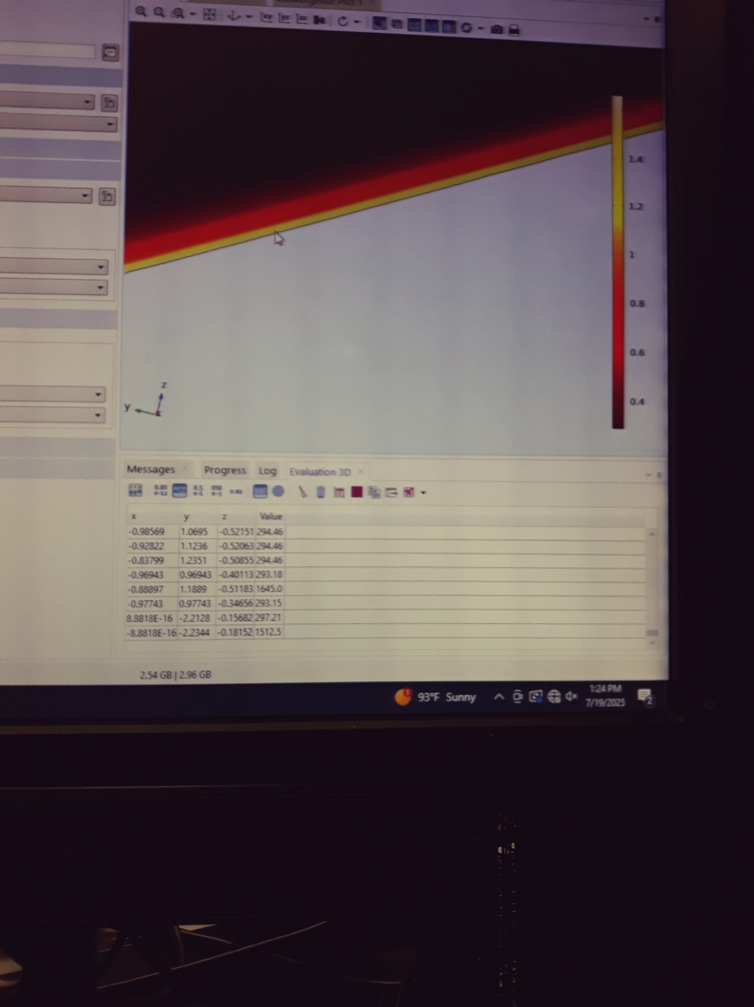

Figure 4: At about 153 seconds into the trajectory in the peak heat flux region, we see that the inside of the capsule maintains room temperature even though the outside gets immensely hot. Inside is at 294.46 kelvin while outside on the heat shield surface is 1512.5 kelvin
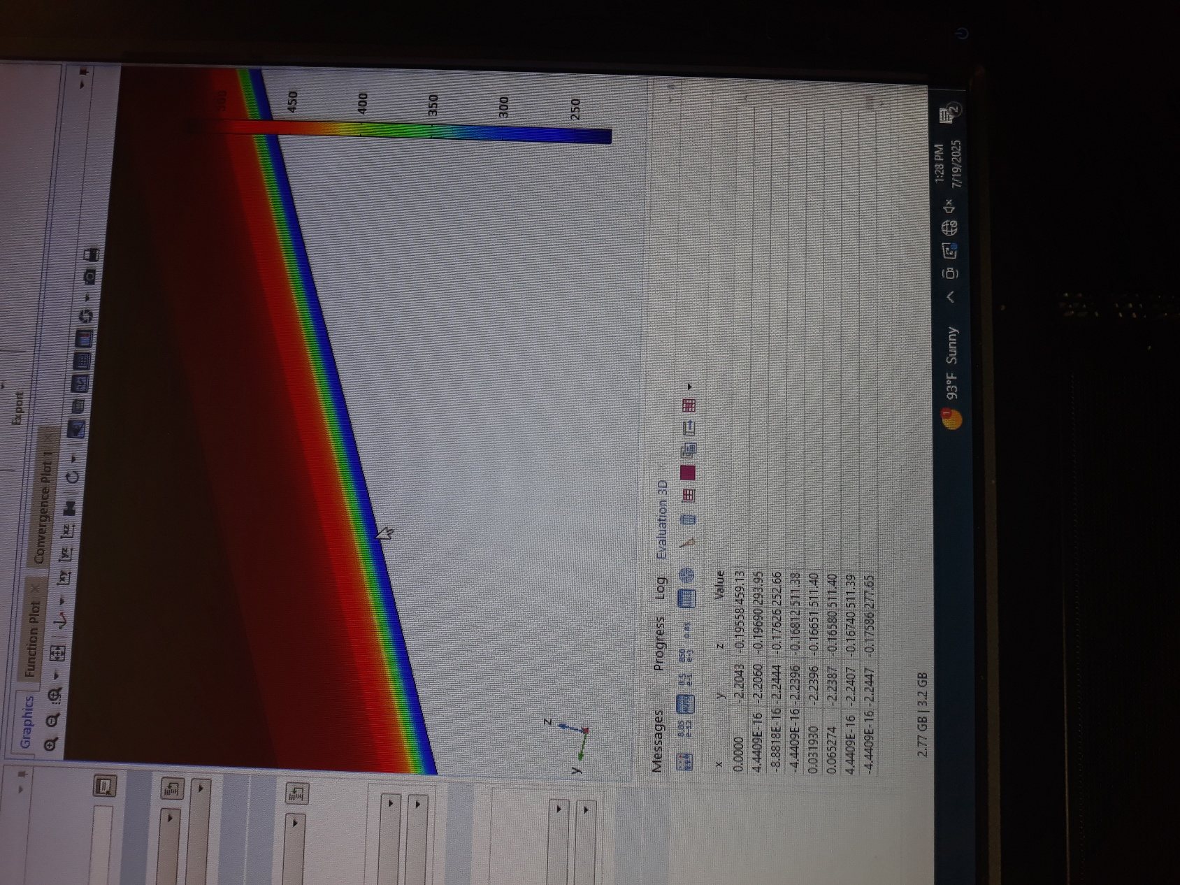

Figure 5: shows ablator composite density change at the same time mentioned in Figure 4. We see that the gradient does not touch anywhere near the aluminum base which is a good sign. The overall density outside is 277.6$\frac{kg}{m^{3}}$ and the inside region maintains close to a virgin density.
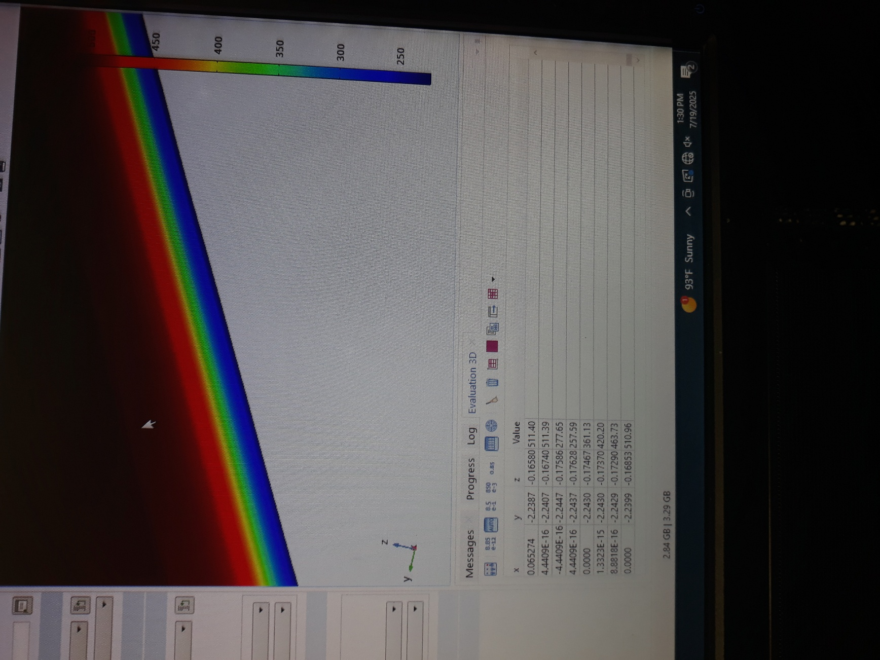

Figure 6: This is the density gradient at the last second at 250 seconds. We are still in the safe zone where the region close to the aluminum base has not seen any significant change.
CONCLUSION
The simulation of two different ablative material revealed key thermal protection characteristics, with both materials exhibiting a density gradient in the safer zone, where the material had not yet reached the aluminum base. This gradient suggests effective heat mitigation, as the material’s density decreases away from the base, likely reducing thermal stress. Additionally, the temperature within the capsule remained stable at or near room temperature throughout the simulation, thereby confirming the material’s ability to effectively insulate and prevent heat transfer to the substrate. These findings suggest that both materials show strong potential for use in thermal protection systems, providing an effective shield against high heat fluxes in the aerospace or similar applications

References

[1] Tahsini, Amir Mahdi, and Samaneh Tadayon Mousavi. “Ablative Heat Shield Design for Reentry Vehicles Using Numerical Analysis.” Applied Mechanics and Materials, vol. 598, 2020,
pp. 298-303. https://doi.org/10.4028/www.scientific.net/AMM.598.298

[2] Alestra, Stephane, Jean Collinet, and Francois Dubois. “Heat Flux Estimation for Materials with Pyrolysis and Ablation.” International Journal of Engineering Systems Modelling and Simulation, vol.2,2009, doi:10.1504/IJESMS.2010.031876.

